[Health & Science](http://www.washingtonpost.com/national/health-science)

**Effort to reduce harm in hospitals centers on seeing patient as a person** By [Lena H. Sun](http://www.washingtonpost.com/people/lena-h-sun) April 8 2015 at 7:43 PM 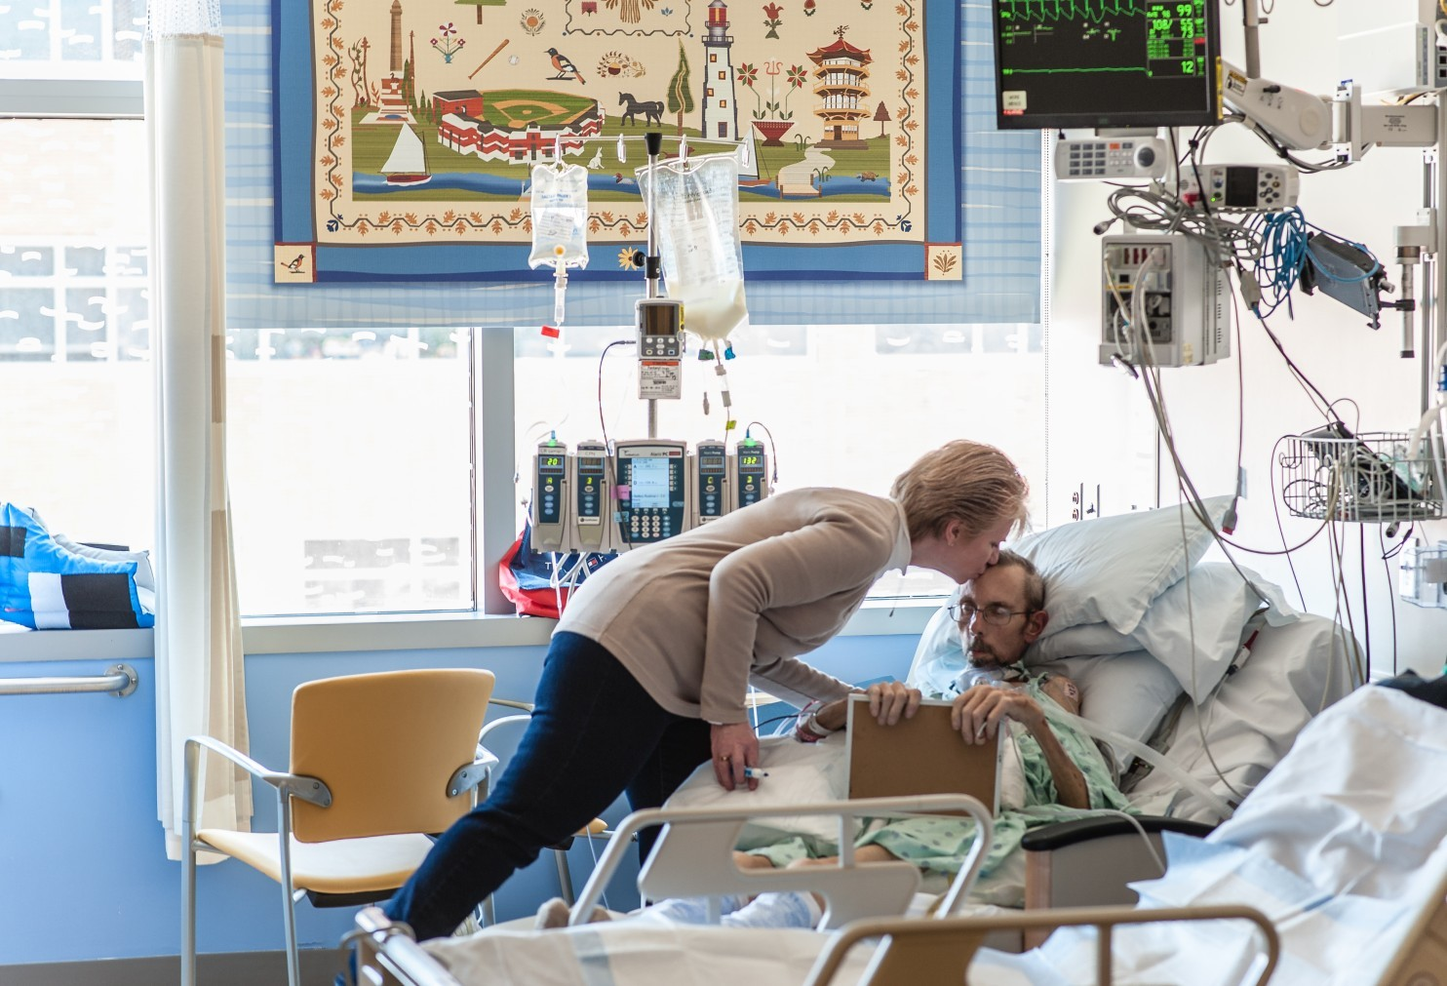  
Lisa Mox and her husband, Joseph, who is now cancer-free after bouts of esophageal and colon cancer, are participating in a pilot program at Johns Hopkins Hospital to reduce “preventable harm” in the surgical intensive care unit. The program expands the definition of harm beyond medical complications to include loss of dignity and respect. (André Chung/For The Washington Post)

Hooked up to machines and a breathing tube, Joseph Mox, 55, can’t talk to the doctors and nurses bustling around a Johns Hopkins intensive care unit. But they know he likes to be called Joe, enjoys “NCIS” and relied on his Catholic faith through bouts of colon and esophageal cancer. And they jokingly ask him for a good deal on brakes because they know he used to manage a truck-parts company.

Mox’s personal details were typed into a specially designed iPad by his wife, Lisa. A questionnaire on the tablet, provided by the hospital, also posed a list of intimate questions for her husband: What do you fear most about the ICU? What brings you joy? What gives you strength?

This is a screen shot of a page in the iPad given to families in the Hopkins pilot. (Johns Hopkins Medicine)

Such questions aren’t normally asked in ICUs, where nurses and doctors are often rushing to keep desperately ill patients alive. But the questions are part of an ambitious experiment at Hopkins and three other hospitals to retool the ICU not only to make it safer but also to make it more humane.

The goal is to redesign the workflow, culture and behavior to reduce “preventable harms” to patients. Harms include medical complications, such as pneumonia. But this pilot effort also considers treating patients with a lack of respect and dignity as “a preventable harm,” something akin to an infection or a blood clot.

*[*[*One in 25 patients in U.S. hospitals acquires an infection during care*](http://www.washingtonpost.com/news/to-your-health/wp/2014/03/26/one-in-25-patients-has-an-infection-acquired-during-hospital-stay-cdc-says/)*]*

The program is part of a fundamental change in health care that is giving top priority to improving the experience of the patient, an aspect of care that too often has been overlooked. “Respecting me [as a patient] is treating me like a human being and knowing what I value and what I care about,”said Peter Pronovost, director of Hopkins’s Armstrong Institute for Patient Safety and Quality.

Increasingly, government payments are tied to the quality of care and patient satisfaction, as opposed to the quantity of services provided. Even so, reorganizing the ICU or other parts of hospitals is time-consuming and costly. Hospitals know they need to do better but seldom have the resources or time to know what will work best, said Knitasha Washington, a consultant who has worked with dozens of health systems seeking to improve their performance.

“You have to make certain that you’re teaching everybody from the environmental engineers to the nurse putting in the IV to the board chair,” she said.

Sometimes changes can be simple but profound. At Boston’s Brigham and Women’s Hospital, in the ICU that is also taking part in the pilot program, nurses start their shifts by asking patients: “What is the most important thing we can do for you today?”

Often, the answer is four hours of sleep or a shampoo. “That one hair wash makes them feel like a million bucks,” said Kathleen Leone, who oversees nursing care in the unit. “And had you not asked that question, you might not have known that about the patient.”

Five million Americans end up in ICUs every year; 1 in 5 patients suffer harm, much of it preventable. Often desperately ill, these patients are at their most vulnerable, stripped of their clothes and their privacy. Harried doctors and nurses sometime miss the bigger picture of patients’ needs and wishes, experts say.

The other two hospitals involved in the ICU effort are Beth Israel Deaconess Medical Center in Boston and the University of California, San Francisco Medical Center. Each facility is trying different ways to transform both medical and nonmedical care.

Furthest along are experiments to cut down on medical errors and injuries. Using Web-based tools and apps, specialists are trying to help clinicians manage the hundreds of complicated tasks that involve each ICU patient.

Beth Israel is developing a dashboard that alerts staffers when the ICU may be experiencing a problem, such as a shortage of nurses for the number of patients.

At Hopkins, clinicians are using a special tablet to see at a glance key indicators for patients. It shows, for example, whether heparin was given to prevent harmful blood clots, or whether the head of the bed is at a 30-degree angle to prevent fluid buildup in the patient’s lungs and pneumonia. This “harms monitor” shows red if a task hasn’t been done properly and green if all steps have been completed.

  
Senior nurse Cindy Dwyer demonstrates the “harms monitor” where clinicians can see key indicators at a glance to know whether proper steps have been taken for a hypothetical patient in the surgical intensive care unit at Johns Hopkins Hospital in Baltimore. (André Chung/For The Washington Post)

Without the tablet, doctors and nurses have to search for that information in many locations, “often 35 different [computer] clicks through multiple different pages,” said Cindy Dwyer, the senior nurse coordinating the pilot program in Hopkins’s surgical ICU.

Defining, measuring and fixing nonmedical injury, such as the loss of dignity and respect, is harder but just as important, say hospital officials and patient advocates.

At Beth Israel, that effort extends beyond the ICU to the entire hospital. Officials are tightening procedures on patients’ personal possessions, too many of which go missing, they said. And they are advising doctors and nurses to be more sensitive about how they talk about patients to other clinicians because those conversations can be overheard.

“For us, it’s like ‘duh,’ ” said Washington, the hospital consultant who is also executive director of the nonprofit group, Consumers Advancing Patient Safety, based in Chicago. But doctors and nurses can become desensitized over time, she said.

Improving communication is key to all four hospitals’ efforts to retool the ICU. Using hospital-provided tablets and other Web tools, patients and families can send questions to their medical team, view test results and medication lists, read their doctors’ plans for their care, and express their own treatment goals.

A 2014 Consumer Reports [survey](http://www.consumerreports.org/cro/magazine/2015/02/the-surprising-way-to-stay-safe-in-the-hospital/index.htm) of 1,200 patients found that those who said they rarely received respect from hospital staff were 2½ times as likely to experience a preventable medical error, such as a hospital-acquired infection, as those who felt they were usually treated with respect.

“Respect and dignity, these aren’t super-abstract concepts,” Pronovost said.

That’s especially true in talking to patients about possible end-of-life treatment, something that often isn’t done except in dire cases. Although a surgeon might view death as the worst possible outcome, a patient might not want to live with intense suffering, said Rebecca Aslakson, a Hopkins palliative care doctor who oversees this aspect of the pilot.

*[*[*Videos help patients understand medical options at the end of life*](http://www.washingtonpost.com/national/health-science/videos-aim-to-inform-patients-about-their-medical-options-at-the-end-of-life/2014/06/02/b0eae002-c63f-11e3-8b9a-8e0977a24aeb_story.html)*]*

The ICU pilots are being funded by $26.5 million in grants from the Gordon and Betty Moore Foundation in California. Gordon Moore is a co-founder of Intel. After his wife Betty’s experience at a California hospital more than a decade ago, the foundation began paying for programs to improve patient safety.

Lisa Mox, who works as an occupational therapy assistant, spends several hours a day at Hopkins with her husband before heading home to Catonsville, Md., to care for their 14-year-old son, Joey. Using the tablet, she was able to coordinate with staff for one of her husband’s sisters to cut and shampoo his hair.

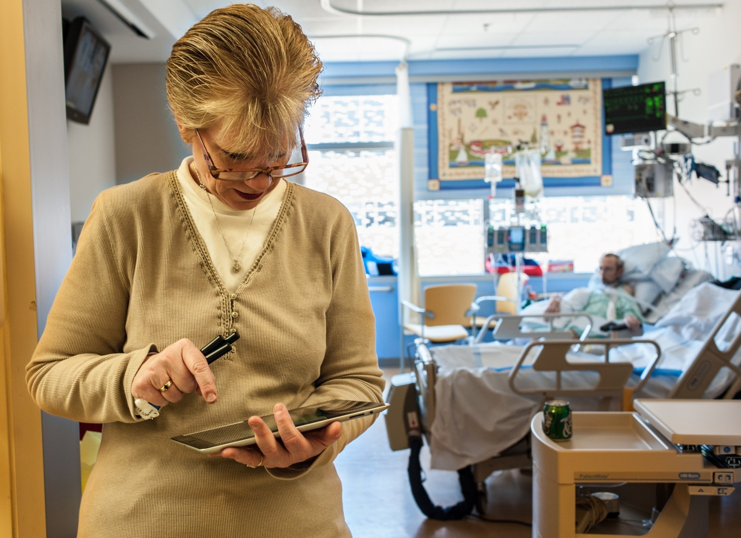  
Lisa Mox, whose husband, Joe, has been fighting esophageal cancer, demonstrates how she uses a hospital-provided tablet to share personal information about him with his medical team. (André Chung/For The Washington Post)

Lisa says she’s feeling less anxious about her husband because his doctors know he’s not just the cancer patient in Room 52. The hospital can tell who on his medical team has looked at his information.

She also uploaded a photo of Joe to his patient profile. The photo is from a family vacation several years ago. The 5-foot-11-inch Mox, in sunglasses, shorts and T-shirt, weighed about 220 pounds, about twice his current weight.

“They saw the photo of him, and that was kind of nice because they didn’t realize how big he was at one time,” she said. “It’s a very different photo than what he looks like now.”

  
Joe Mox, pictured here with son Joey and wife Lisa, during family vacation several years ago. (Family photo)

[](http://www.washingtonpost.com/people/lena-h-sun)

Lena H. Sun is a national reporter for The Washington Post, focusing on health.