[To Your Health](http://www.washingtonpost.com/news/to-your-health)

**Loneliness can literally hurt your heart, scientists say**

By [Ariana Eunjung Cha](http://www.washingtonpost.com/people/ariana-eunjung-cha) April 20 at 3:43 PM

(Bigstock)

That pang in the middle of your chest when you feel lonely may not just be in your head. Researchers reported in the journal [Heart](http://heart.bmj.com/content/early/2016/03/15/heartjnl-2015-308790.full) this week that poor social relationships could actually hurt your heart.

The study involved what is known as a meta-analysis of 23 previous studies involving 181,000 people. This involves taking the raw data, pooling it and reanalyzing it. In total, the studies included 4,628 cases of cardiovascular disease and 3,002 stroke. cases The researchers found that being lonely or socially isolated appeared to be associated with a 29 percent increase in risk of heart disease and with a 32 percent increase in risk of stroke.

The paper supports previous work about the link between mental health and aspects of physical health, from immune functioning to cognitive decline. The magnitude of the effect of loneliness appeared to be similar to that of other stressors, such as anxiety and job strain, and appeared to be similar for both men and women.

*[*[*Loneliness grows from individual ache to public health hazard*](https://www.washingtonpost.com/national/health-science/loneliness-grows-from-individual-ache-to-public-health-hazard/2016/01/31/cf246c56-ba20-11e5-99f3-184bc379b12d_story.html)*]*

Nicole K. Valtorta, a researcher at the University of York, and her co-authors said their work "suggests that addressing loneliness and social isolation may have an important role in the prevention of two of the leading causes of morbidity in high-income countries." She suggested interventions, such as educational programs, social activities and cognitive-behavioral therapy.

"Risk factors for loneliness and social isolation such as gender, socioeconomic position, bereavement and health status, are well- established and hold the key to identifying people who may benefit from intervention," they wrote.

Here is a flowchart of how social connections might impact your heart health and stroke risk, by Julianne Holt-Lunstad and Timothy B. Smith of Brigham Young University. They wrote an opinion piece accompanying Valtorta's paper.

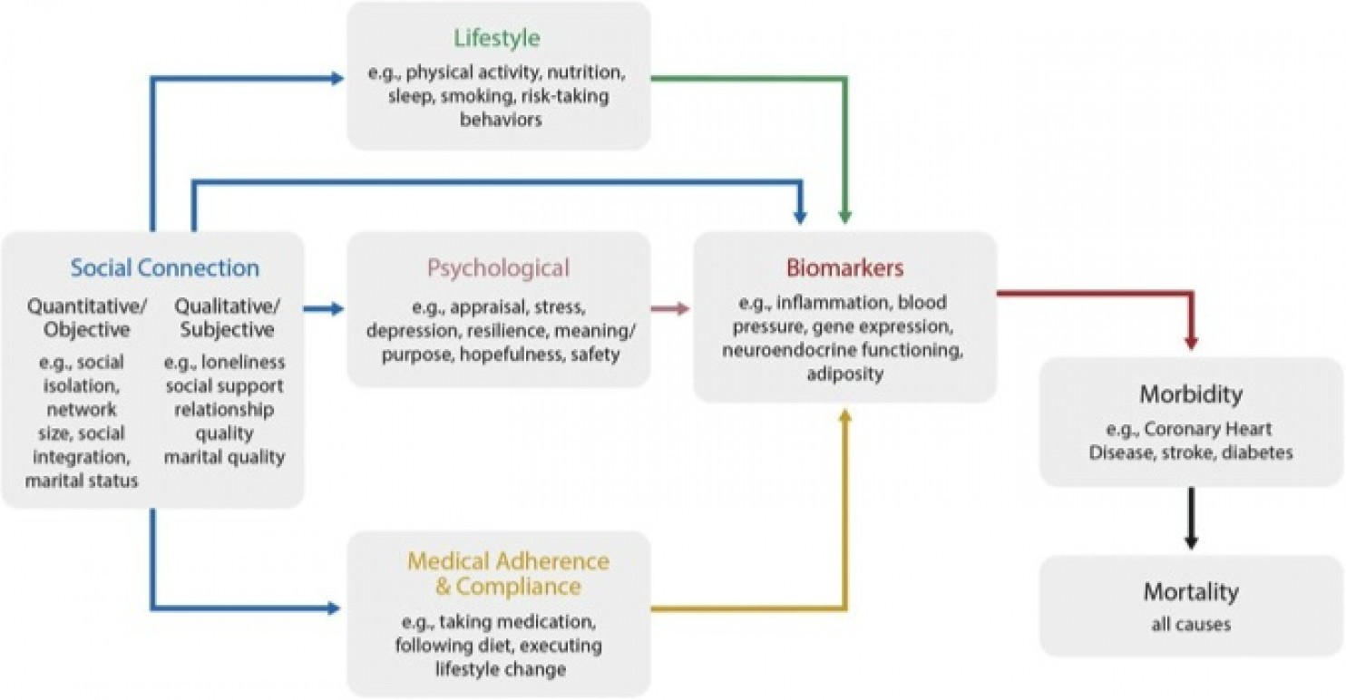  
Simplified model of possible direct and indirect pathways by which social connections influence disease morbidity and mortality. (Heart)

A study published last year by University of Chicago researchers said that loneliness may cause humans to fall apart at even the cellular level. They wrote that the emotion appears to increase activities in genes that produce inflammation and those that fight disease.

Psychologist John Cacioppo wrote in his book, "Loneliness," that it is "a survival impulse" like hunger.

To Your Health newsletter

Health news and research, in your inbox weekly.

Cacioppo told the [University of Chicago magazine](http://magazine.uchicago.edu/1012/features/the-nature-of-loneliness.shtml) that it's "a powerful evolutionary force binding prehistoric people to those they relied on for food, shelter, and protection, to help them raise their young and carry on their genetic legacy." He hypothesized that "the distress they felt if they drifted toward the outskirts of their group served as a warning to reengage or else perish."

While Valtorta's study is the first to conduct a systematic analysis of this data, it is limited by the fact the studies all used different criteria to determine whether someone has poor social relationships. Some papers used a loneliness measure, others a social isolation measure, and still others combined criteria. The review also included one paper from as far back as 1965, and given how much our management of heart disease has changed since then, it's possible that data may not really be relevant to modern-day patients.

The authors also noted that "we cannot infer causality from our findings, nor can we exclude confounding by unmeasured common causes, or reverse causation if deficiencies in social relationships are the result of subclinical disease."